Aim: To understand the process of convolution over the image and apply over the classification problem
IDE: Google Colab

Theory:
Convolutional Neural Networks (CNN) are complex feed forward neural networks. CNNs are used for image classification and recognition because of its high accuracy There are three types of layers in a convolutional neural network: i. Convolutional layer ii. Pooling layer iii. Fully connected layer Each of these layers has different parameters that can be optimized and performs a different task on the input data.

What is Pooling Layer?
Pooling layer is responsible for reducing the spatial size of the Convolved Feature. This is to decrease the computational power required to process the data through dimensionality reduction. There are two types of Pooling i. Average Pooling. ii. Max Pooling Max Pooling returns the maximum value from the portion of the image covered by the Kernel. On the other hand, Average Pooling returns the average of all the values from the portion of the image covered by the Kernel. Max Pooling also performs as a Noise Suppressant. It discards the noisy activations altogether and also performs de-noising along with dimensionality reduction. On the other hand, Average Pooling simply performs dimensionality reduction as a noise suppressing mechanism. Hence, we can say that Max Pooling performs a lot better than Average Pooling.

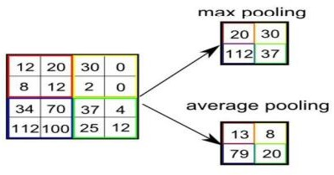

What is Convolutional Layer?
Convolutional layers are the major building blocks used in convolutional neural networks. A convolution is the simple application of a filter to an input that results in an activation. Repeated application of the same filter to an input results in a map of activations called a feature map, indicating the locations and strength of a detected feature in an input, such as an image. A convolutional layer contains a set of filters whose parameters need to be learned. The height and weight of the filters are smaller than those of the input volume. Each filter is convolved with the input volume to compute an activation map made of neurons.

What is Fully Connected Layer?
A fully connected layer that takes the output of convolution/pooling and predicts the best label to describe the image We have three layers in the full connection step i. Input layer ii. Fully-connected layer iii. Output layer

Input Layer: It takes the output of the previous layers, “flattens” them and turns them into a single vector that can be an input for the next stage.

Fully Connected Layer: It takes the inputs from the feature analysis and applies weights to predict the correct label.

Output Layer: It gives the final probabilities for each label.
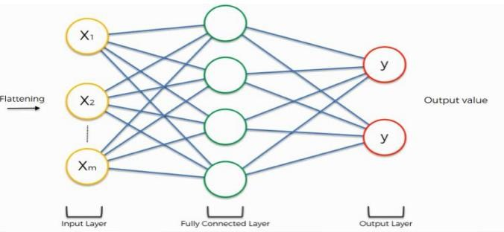

ReLU Layer: ReLU is an activation function. Rectified Linear Unit (ReLU) transform function only activates a node if the input is above a certain quantity, while the input is below zero, the output is zero, but when the input rises above a certain threshold, it has a linear relationship with the dependent variable. The main aim is to remove all the negative values from the convolution. All the positive values remain the same but all the negative values get changed to zero.

Methodology:
- Load the basic libraries and packages
- Load the dataset
- Analyse the dataset
- Normalize the data
- Pre-process the data
- Visualize the Data

- Write the CNN model function
- Write the Cost Function
- Write the Gradient Descent optimization algorithm
- Apply the training over the dataset to minimize the loss
- Observe the cost function vs iterations learning curve

Program (Code):

#import libraries
import numpy as np
import pandas as pd
import matplotlib.pyplot as plt
import keras
from keras.datasets import fashion_mnist
import keras.models as models
import keras.layers as layers
from keras import regularizers
from keras.layers import Dropout
import tensorflow as tf
from tensorflow.keras.models import Sequential, Model
from tensorflow.keras.layers import Dense,Activation,Flatten,Dropout,Conv2D, MaxPooling2D, LeakyReLU
from tensorflow.keras.utils import to_categorical #for the categorical data
print(keras.__version__)

#import the dataset #x: Images and Y: labels of the images
(train_X,train_Y),(test_X,test_Y)=fashion_mnist.load_data()
plt.imshow(train_X[0])
print(train_Y[0])
print(train_X.shape,train_Y.shape)
print(test_X.shape, test_Y.shape)
classes=np.unique(train_Y)
nClasses=len(classes)
print(classes)
print(nClasses)
train_X=train_X.reshape(-1,28,28,1)
test_X=test_X.reshape(-1,28,28,1)
print(train_X.shape,train_Y.shape)
print(test_X.shape, test_Y.shape)
#converting the values of the pixels from 0-1
#type-conversion
train_X=train_X.astype('float32')
test_X=test_X.astype('float32')
train_X=train_X/255
test_X=test_X/255
train_Y_one_hot=to_categorical(train_Y)
test_Y_one_hot=to_categorical(test_Y)
train_Y[0]
train_Y_one_hot[0]
from sklearn.model_selection import train_test_split
train_X,valid_X,train_label,valid_label=train_test_split(train_X,train_Y_one_hot,test_size=0.2,random_state=13)
train_X.shape,valid_X.shape,train_label.shape,valid_label.shape
batch_size=64
epochs=20
num_classes=10
model=tf.keras.Sequential()
#1st hidden layer
model.add(tf.keras.layers.Conv2D(32,(3,3),activation="linear",padding='same'))
model.add(tf.keras.layers.LeakyReLU(alpha=0.1))
model.add(tf.keras.layers.MaxPooling2D(pool_size=(2,2),padding='same'))
#2nd hidden layer
model.add(tf.keras.layers.Conv2D(64,(3,3),activation="linear",padding='same'))
model.add(tf.keras.layers.LeakyReLU(alpha=0.1))
model.add(tf.keras.layers.MaxPooling2D(pool_size=(2,2),padding='same'))
#3rd hidden layer
model.add(tf.keras.layers.Conv2D(128,(3,3),activation="linear",padding='same'))
model.add(tf.keras.layers.LeakyReLU(alpha=0.1))
model.add(tf.keras.layers.MaxPooling2D(pool_size=(2,2),padding='same'))
model.add(tf.keras.layers.Flatten())
model.add(tf.keras.layers.Dense(128,activation='linear'))
model.add(tf.keras.layers.LeakyReLU(alpha=0.1))
model.add(tf.keras.layers.Dense(num_classes,activation='softmax'))#output final layer
model.compile(loss=tf.keras.losses.categorical_crossentropy,optimizer=tf.keras.optimizers.Adam(),metrics=['accuracy'])
48000/64
model_train=model.fit(train_X,train_label,batch_size=64,epochs=20,verbose=1,validation_data=(valid_X,valid_label))
testing_evaluation=model.evaluate(test_X,test_Y_one_hot)
testing_evaluation #loss,accuracy
model_train.history
accuracy=model_train.history['accuracy']
val_accuracy=model_train.history['val_accuracy']
loss=model_train.history['loss']
val_loss=model_train.history['val_loss']
epochs=range(len(accuracy))
plt.plot(epochs,accuracy,label='training accuracy')
plt.plot(epochs,val_accuracy,label='validation accuracy')
plt.title('evaluating based on accuracy')
plt.legend()
plt.show()
plt.plot(epochs,loss,label='training loss')
plt.plot(epochs,val_loss,label='validation loss')
plt.title('evaluating based on loss')
plt.legend()
plt.show()
regmodel=tf.keras.Sequential()
#1st hidden layer
regmodel.add(tf.keras.layers.Conv2D(32,(3,3),activation="linear",padding='same'))
regmodel.add(tf.keras.layers.LeakyReLU(alpha=0.1))
regmodel.add(tf.keras.layers.MaxPooling2D(pool_size=(2,2),padding='same'))
regmodel.add(tf.keras.layers.Dropout(0.25))
#2nd hidden layer
regmodel.add(tf.keras.layers.Conv2D(64,(3,3),activation="linear",padding='same'))
regmodel.add(tf.keras.layers.LeakyReLU(alpha=0.1))
regmodel.add(tf.keras.layers.MaxPooling2D(pool_size=(2,2),padding='same'))
regmodel.add(tf.keras.layers.Dropout(0.25))
#3rd hidden layer
regmodel.add(tf.keras.layers.Conv2D(128,(3,3),activation="linear",padding='same'))
regmodel.add(tf.keras.layers.LeakyReLU(alpha=0.1))
regmodel.add(tf.keras.layers.MaxPooling2D(pool_size=(2,2),padding='same'))
regmodel.add(tf.keras.layers.Dropout(0.40))

regmodel.add(tf.keras.layers.Flatten())
regmodel.add(tf.keras.layers.Dense(128,activation='linear'))
regmodel.add(tf.keras.layers.LeakyReLU(alpha=0.1))
regmodel.add(tf.keras.layers.Dropout(0.3))
regmodel.add(tf.keras.layers.Dense(num_classes,activation='softmax'))#output final layer
regmodel.compile(loss=tf.keras.losses.categorical_crossentropy,optimizer=tf.keras.optimizers.Adam(),metrics=['accuracy'])
reg_model_train=regmodel.fit(train_X,train_label,batch_size=64,epochs=20,verbose=1,validation_data=(valid_X,valid_label))

Results:

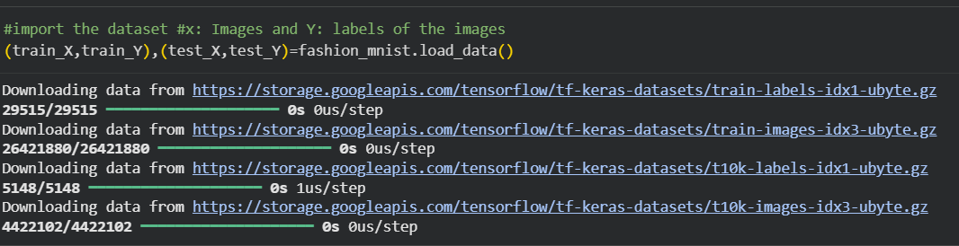

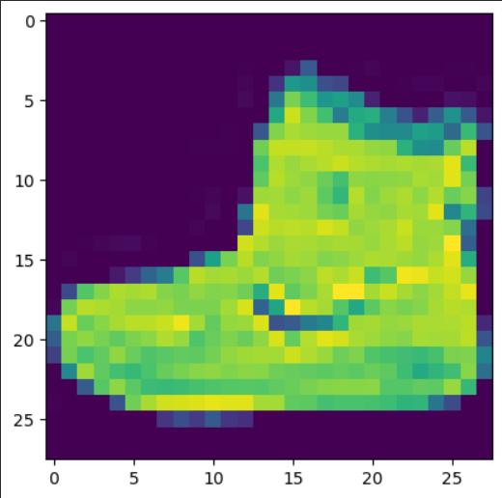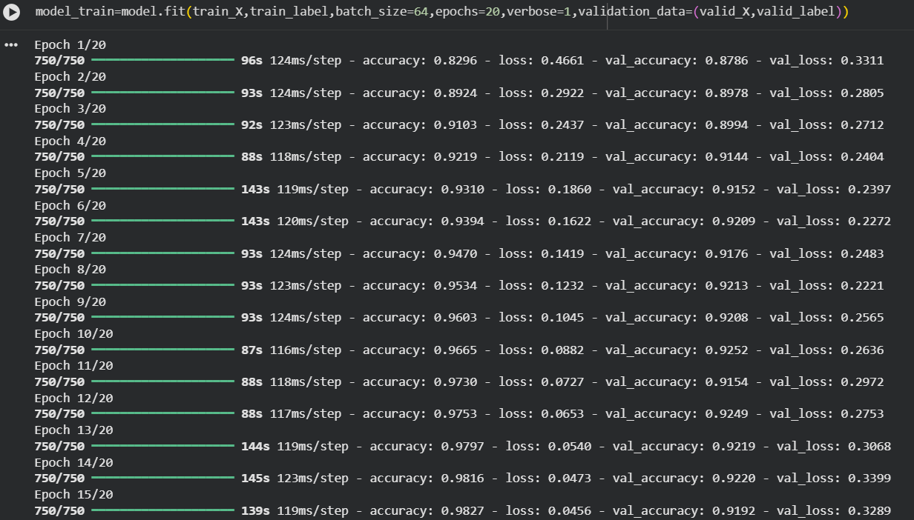

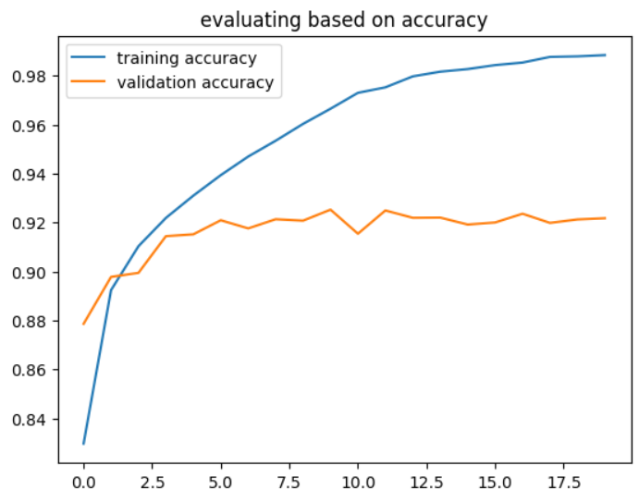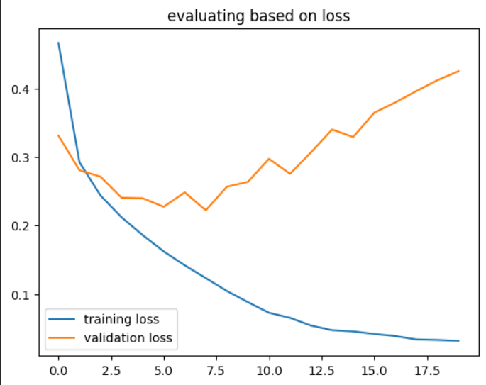

Pre Lab Exercise:

- What is Convolution process? Explain giving example.
Convolution is a mathematical operation used in CNN to extract important features from an image using a filter (kernel).
The filter slides over the image and performs multiplication and addition to produce a feature map.
$$y(i,j)=\sum_{m}{\sum_{n}{x(i-m,j-n)h(m,n)}}$$
Example: detecting edges, shapes, textures from images.

- What are different layers in CNN model?
- Input layer – takes image as input
- Convolution layer – extracts features
- Activation layer (ReLU) – adds non-linearity
- Pooling layer – reduces feature size
- Flatten layer – converts matrix to vector
- Fully connected layer – performs classification
- Output layer – gives final result

c. What is the requirement of the pooling layer in the CNN model?

Pooling layer is used to reduce the size of feature maps.
Advantages:
- reduces computation
- prevents overfitting
- keeps important features
- makes model faster
Common types:
- Max pooling
- Average pooling

  - What is the requirement of the use of ReLU activation function after convolution step?
Requirement of ReLU after convolution
ReLU activation function is used after convolution to introduce non-linearity, so the CNN can learn complex patterns.
It converts negative values to zero and keeps positive values unchanged.
$$f(x)=max⁡(0,x)$$

Benefits:
- learns complex features
- makes training faster
- removes negative values

Observation and Result Analysis:

- Nature of the dataset
The dataset contains input features and target labels used to train the model.
It can be:

- structured (table format)
- images
- text
- numerical values

Dataset is usually divided into:

- training data
- validation/test data

- Training Process without regularization
Without regularization, the model tries to fit training data very closely.

Effects:

- very low training error
- high chance of overfitting
- poor performance on new data

Model learns noise along with actual patterns.

- After regularization in the training Process
Regularization controls model complexity by adding penalty.

Common techniques:

- L1 regularization
- L2 regularization
- Dropout

Effects:

- reduces overfitting
- improves generalization
- slightly increases training error but improves test accuracy

d. Observation over the Learning Curves

Learning curve shows performance vs training time.
Observation:
- Without regularization → training accuracy high, validation accuracy low (overfitting)
- With regularization → training and validation curves closer
- model becomes more stable and generalizes better

Post Lab Exercise:

Why CNN is preferred over ANN for images

CNN is preferred because it can automatically detect important features like edges, shapes, and textures using convolution filters.

Advantages over ANN:

fewer parameters

preserves spatial information

better accuracy for images

reduces overfitting

Can CNN be applied over Text data? If yes, then how. If no, then why?

Yes, CNN can be applied to text data.

Text is first converted into numeric vectors using:

Bag of Words

TF-IDF

Word Embeddings (Word2Vec, GloVe)

Then CNN detects patterns like:

important words

phrases

sentence features

Applications:

sentiment analysis

spam detection

text classification

What is the role of dropout layer?

Dropout layer randomly turns off some neurons during training.

Purpose:

prevents overfitting

improves generalization

makes model more robust

What will happen if maxpooling is replaced with minpooling?

Max pooling selects the largest value (important feature).

Min pooling selects the smallest value, which may ignore important features.

Result:

important information may be lost

model accuracy may decrease

poor feature extraction

